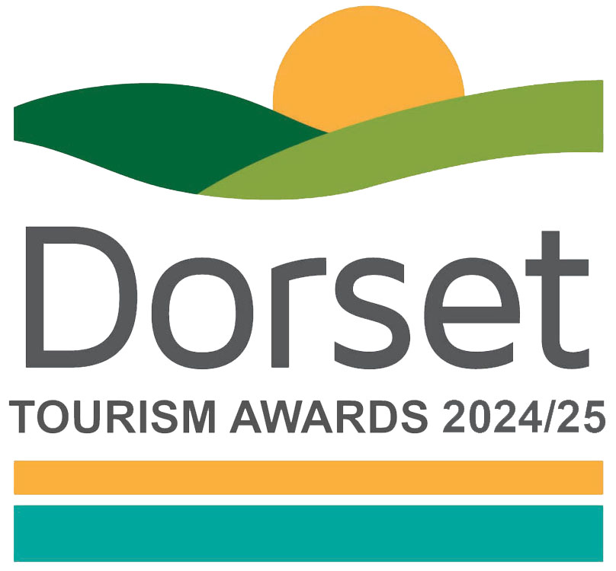

Future of Hospitality Award

This special award in conjunction with NFU Mutual’s Bournemouth Agency recognises businesses that are recruiting and developing hospitality stars of the future, providing clear and inspiring structured career paths in hospitality.

This could include the recruitment of your team for those just starting out or retraining at a different stage in their life. Skills development, training and engagement can be undertaken either in house or working with others.

Recruitment and development is often cited as one of the big challenges and this award specifically recognises hospitality businesses that have both a genuine commitment to and are innovative in their recruitment and development.

Sponsored by NFU Mutual Bournemouth

Eligibility criteria

Businesses can nominate themselves or may be nominated by a third party but they should be directly involved in tourism, making a contribution to the visitor economy with a significant proportion of business generated by people visiting from outside the local area.
They should meet the tourism product definition:
Only tourism businesses who directly serve the end-users are eligible (i.e. the tourist/ visitor/ guest). Business to business agencies or intermediaries e.g. that manage business to consumer (B2C) presence for tourism businesses; would not be eligible
'Tourism product' covers a number of different categories including:
• Accommodation e.g. hotels, bed & breakfasts, guest houses, self-catering/serviced apartments, hostels, holiday boats, camping, caravanning, glamping, lodges, shepherds huts, chalets
• Hospitality i.e. a single food and beverage service business e.g. pub, restaurant, café, tea room, coffee shop, bistros, food and drink markets, kiosks & street food (in a regular location). [For these purposes the definition of a food and drink market is a collection of independent food and drink establishments with ancillary services (e.g. parking area, toilets, security, visitor information) and maintained by a management firm as an entity.]
• Transport services e.g. rail, road, water, airports and rental
• Guided tours
• Cultural services, e.g. theatres, musical entertainment venues, sporting venues
• Travel agencies and other reservation services, including tour operators and destination management companies
• Sporting, adventure and recreational activities
• Visitor attractions that meet the visitor attraction definition: a permanently established excursion destination, a primary purpose of which is to allow access for entertainment, interest, or education and can include places of worship; rather than being primarily a retail outlet or a venue for sporting, theatrical, or film performances. It must be open to the public, with or without prior booking, for published periods each year, and should be capable of attracting day visitors or tourists as well as local residents
• Businesses of all sizes can apply as this category is judged within the context and style of the business

PLEASE RETURN YOUR COMPLETED FORM BY THE CLOSING DATE TO awards@services4tourism.co.uk

Nominator’s details
Name of Nominator (you):
Enter your name, business name, email and phone number here.

Does the business know that they are being nominated?
Enter ‘yes’ or ‘no’ here.

Entrant/business details
Contact name and job title for the business you are nominating to win this award, if different from above:
Enter the contact name job title here.

Business phone number:
Enter the phone number here.

Business email:
Enter email here.

Business name:
Name of business application relates to. Give the name used to promote the business, as you wish it to appear in all publicity materials, on certificates, in presentations etc.:
Enter business name here.

Business address:
Enter the business address here.

If known, list any awards, ratings, accolades received in the last two years, relating to training and your team. Include the title, awarding body, level and date achieved.

Enter information on any awards, ratings or accolades here.

Online presence and reviews
Provide links to the businesses online presence
Website
Enter the website URL here.

Social Media Platforms
If known, provide links to all business pages/profiles on Facebook, Instagram etc. and Twitter handles
Enter social media details here.

Application
Please provide a detailed explanation of what the business is doing to recruit, train and develop the hospitality stars of the future and why they should win (500 words maximum).

Enter your answer here.

Links to any relevant websites to support this entry (optional):
Enter web links to supplementary evidence here.

